# Order Data analysis (Joins)

## Problem Statement: What is the daily product revenue for CLOSED or COMPLETE orders?

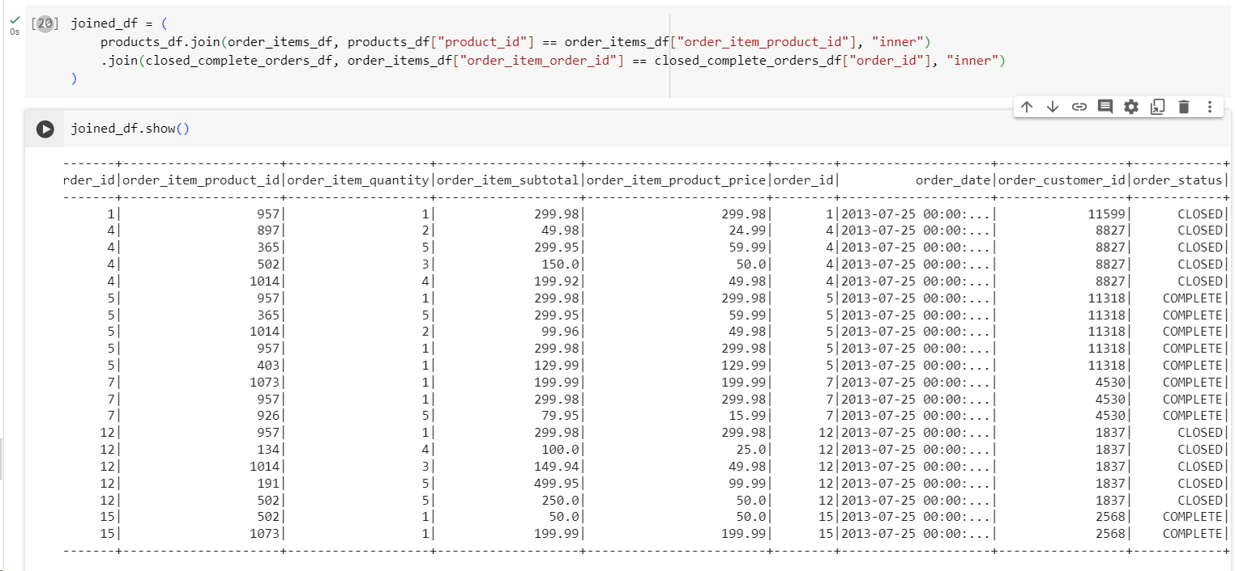

## Load the required data in to DF like categories, customer, departments, order_items, orders and products

### Categories

### Customer

### Departments

### order_items

### Orders

### Products

## Get the count for each order status

## Filter only COMPLETE or CLOSED orders

## Join the products , order_items and orders tables and calculate daily product revenue

## Write the data in to the table Daily product revenue in Hive

